Dulcimer 102: Mapping the Dulcimer with Scales and Chords

Introduction
In this workshop we will discuss the basic map of the hammered dulcimer. The dulcimer is a relatively easy instrument to play because of the repeated notes throughout the soundboard. The trick to playing smoothly is to primarily use alternating left and right hand patterns and understanding where to find the best crossover points over the bridges. We also will discuss relative minor keys and the “modes” of music.

Learning the Four – Four (4-4) and Five –Three (5-3) Patterns
The example below left shows a basic four on one side four on the other side figure (4–4.) Start with the left hand on any “marked” note. The example below shows the key of G. This basic pattern will also work in the key of D, key of C, key of F and on bigger dulcimer, the key of A; as long as you start on a marked note. The five on one side and three on the other side pattern uses the same “notes” as the 4-4 pattern but we start with the right hand and crossover from the D to the E. This will require a demonstration. The example on the right shows a two-octave scale that starts in the lower octave with a 4–4 pattern and transitions into a 5-3 pattern in the upper octave.
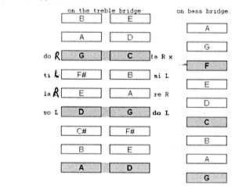
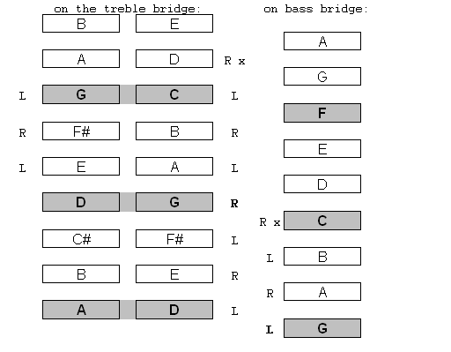

Basic 4-4 figure single octave scale – Start L Two octave scale: 4–4 Lower octave; 5–3 upper octave
Note crossover point (x) from C to D Note: 5–3 crossover point (x) from D to E
Exercises:
Single Octave Scale 4–4: Start → L on the treble bridge low G - Crossover point C to D 5–3: Start → R on the treble bridge low G - Crossover point D to E Play up and down the scale with out repeating the top or bottom note
Double Octave Scale 4–4 into 5-3: Start → L on the bass bridge low G - Continuous two octave scale; watch the crossover points 5–3 into 4-4: Start → R on the bass bridge low G
Basic Arpeggio Chord Exercise: Intervals one – three – five – eight (one)
2-2 into 3-1: Start → L on the treble bridge low G
3-1 into 2-2: Start → R on the treble bridge low G
2-2 into 1-3: Start → R on the treble bridge low G (This one is more advanced; it will be demonstrated)
More Advanced:
I-IV-V Exercise single Low Octave Key of G: use the chords C to G to D - Start –L (Bass bridge) - Start - R (bass bridge)
I-IV-V Exercise Double Octave Key of G: use the chords C to G to D - Start – L (Bass bridge) - Start – R (bass bridge)
Minor Arpeggios: Same as Basic Arpeggio Exercises; Start pattern on one above the marked note (example A above marked G)

Relative Minor Keys:
Every major key has a “relative minor” key. A relative minor scale is a “natural” minor scale that uses all the notes in it’s relative major scale. In the of key C-Major, “A” is its relative minor. This simply means that to play a “natural” minor scale in the key of A, start on an “A” note but use only notes that are used in in key of C-Major. Here are the notes relatively speaking; In he Key of C:
C-Major scale: C-D-E-F-G-A-B-C
Note: There no sharps and flats used in he Key of C (on the piano use only the white notes; C to C)
A-minor scale: A-B-C-D-E-F-G-A
Note: These are all he same notes in the key of C, but starting on A. So “relatively” speaking this is a minor scale. (On the piano use only the white notes; A to A)
Note: Just to make things more complicated, “classically” speaking there are two other types of minor scales, a “harmonic” minor scale and a “melodic” minor scale. You can look those up on your own, but for this workshop let’s just stick to the natural minor.
A Foray into Modes:
I personally don’t find modes all that useful when communicating with other musicians. They are named after terms that the ancient Greeks used, but that is a little bit of a stretch since the Greeks didn’t write down their music nor are there any recordings that survived (Aristotle's Greatest Hits;-) But I will discuss some of the modes, and how they are related to the dulcimer.
Ionian Mode - Do-re-me scale that we used above. This is called a natural “diatonic” scale. On the HD start on any marked note and use a “4-4” pattern above. (C to C white notes on the piano)
Dorian Mode- A “minor” sounding mode that is similar in form to the Ionian mode but a flatted 3rd and 7th (or minor 3rd and minor 7th) are substituted. The dorian mode can be played using the same pattern as we use for a major scale, but start on a note one above any marked note. (I will demonstrate) Celtic and other ethnic music often use the dorian mode. (D to D white notes on piano)
Aeolian Mode - Another name for a natural minor scale. (A to A white notes on the piano)
Mixolydian Mode - Similar to the Ionian mode but a flatted 7th is substituted. Start on any mark note and go straight up and down. (G to G white notes on the piano)
Phrygian Mode - (Not to be confused with the “modern” Phrygian mode.) Using the same (4-4) pattern we used for a major scale start on any note two above any marked note. This will be demonstrated. (E to E white notes on the piano)
About The Author
Cliff Cole fell in love with the hammered dulcimer at the Philadelphia Folk Festival three decades ago, and he’s been hammering on ever since. He started off as a drummer playing rock, jazz, and blues, and then carried that musical experience and sense of rhythm over to the hammered dulcimer and folk music. Rounding out his musical expression, Cliff studies acoustic guitar, plays the blues harp, and enjoys singing.

For many years, Cliff has presented workshops at dulcimer and folk music festivals, including The Cranberry Dulcimer Gathering, Nutmeg Dulcimer Festival, The Pocono Winter Fest and the French Creek Retreat.

Cliff's first regular dulcimer gig was playing Bluegrass with Steel City Strings in the late '80s. He then founded the folk ensemble DayBreak in 1989, and they are still performing together today. The group has delved into many musical styles including Celtic, Old Time, Bluegrass, American folk, early music and their own original tunes, many of which Cliff created and arranged. Over the years, Cliff produced six recordings with DayBreak, including Lost Cave, which was recorded live inside Lost River Caverns in Hellertown, PA. and two recordings with his daughter, accomplished vocalist and poet, Emily Rose Cole. Cliff enjoys collaborating with many musicians.

In addition to playing in DayBreak he plays with two other groups. The Dulcimer Boys, who have an old-time flair, feature Norm Williams on mountain dulcimer (Rob Yoder often joins in too.) Tachyonmetry merges the ethereal hammered dulcimer with the sultry smooth classical guitar played by Brian Person. Brian and Cliff have released a CD named Sunset Waterfall.

Cliff is a founding member of the Quakertown Area Dulcimer and Autoharp Society (QUADAS), serves on the board of Perkasie Patchwork Coffeehouse, and is also member of the Nutmeg Dulcimer Festival Board.

Contact Cliff at:
Cliff Cole
2440 Schukraft Road
Quakertown, PA 18951
215-453-1722
http://www.daybreakfolk.com/
This document can be downloaded from: http://www.daybreakfolk.com/CliffCole.htm

